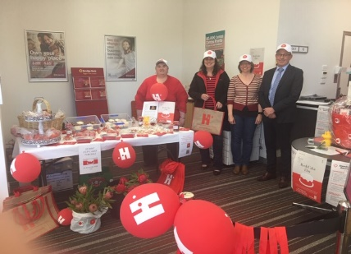
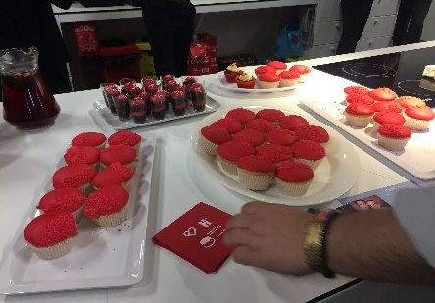
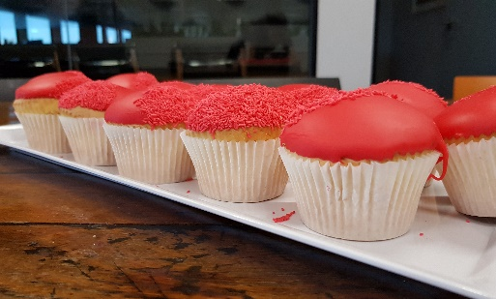
Show your support for the Bleeding Disorders community
and run a Red Cake Day during
Bleeding Disorders Awareness Week 13 – 19 October 2019

Orders can also be placed online at www.haemophilia.org.au/order

REGISTRATION AND ORDER FORM

Contact Name: _________________________________________________________________________________
Organisation/School: ____________________________________________________________________________
Address for delivery: ____________________________________________________________________________
__________________________________________________________________________PCode: ______________
Phone: _______________________________ Email:____________________________________________________

Are you hosting: a Red Cake Day event an Awareness event/stall

Please describe your event/plans
______________________________________________________________________________________________
______________________________________________________________________________________________
______________________________________________________________________________________________
______________________________________________________________________________________________
______________________________________________________________________________________________
I am going to participate in Red Cake Day and raise money for:

National programs and services (HFA) My local Haemophilia Foundation (State) _______

To increase your fundraising efforts, you can set up a personal fundraising page which allows your guests /invitees to see your event details, fundraising target, and through which they can support your event directly. Visit Everyday Hero www.everydayhero.com.au to set this up.

Unfortunately, I am unable to host an event this year, but I would like to make a donation

I would like to donate: $50 $100 $200 Enter an amount $____________

Cheque/money Order enclosed OR Credit Card: VISA Mastercard Amex Diner

Name on card: ____________________________________________
Card Number: __ __ __ __ __ __ __ __ __ __ __ __ __ __ __ __ Expiry Date: ___/___
Signature__________________________________________________

PROMOTIONAL ITEMS ORDER FORM
Please note that some limits are necessary on available items. Unfortunately, once stocks have been exhausted we will be unable to supply items, so early ordering is encouraged. Items will be posted early September.

Item | Limit | No. required
Red Cake Day serviettes (for distribution only to people running Red Cake Day events) | 20
Red Cake Day thank you cards (for distribution only to people running Red Cake Day events) | 20
Donation Envelopes (great tool for events that you can give to people to make a donation and forward directly to us) | 20
Temporary Tattoos ‘H’ design | 100
Balloons | 10
Pens | 20
Colouring-in sheet (Part of the school/kinder pack, extra copies can be downloaded from the HFA website) | 100
Children Pencils (Part of the school/kinder pack, extra copies can be downloaded from the HFA website) | 20
Word Find (Part of the school/kinder pack, extra copies can be downloaded from the HFA website) | 20
Yo-yo’s (to be used as a fundraising tool ~ gold-coin donation) | 10/20 lots
Stickers - Red Cake Day | 100
Stickers – Bleeding Disorder Awareness Week | 100
Awareness Week A3 Poster (information poster) | 5
Red Cake Day promotion A3 Poster | 5
Awareness Week Special Newsletter | 100

PLEASE RETURN FORM:
Haemophilia Foundation Australia
A: 7 Dene Ave Malvern East, VIC 3145
F: 03 9885 1800 E: donate@haemophilia.org.au
Orders also be placed online at www.haemophilia.org.au/order

