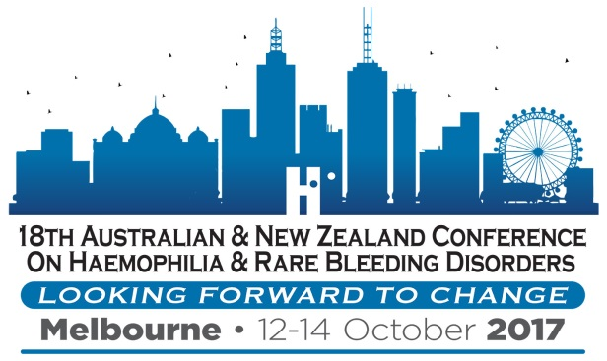

LIMITED FUNDING AVAILABLE FOR NATIONAL CONFERENCE 2017

The 18th Australian & New Zealand Conference on Haemophilia & Rare Bleeding Disorders will be held at Pullman Albert Park Melbourne from 12-14 October 2017.

For information about the conference, registration and accommodation costs visit http://www.haemophilia.org.au/conferences.

- HFA has allocated $15,000 to assist people living with a bleeding disorder, relatives/partners or carers to attend the Conference
- Part funding will be favoured over full funding to increase access to more people
- You will generally be expected to contribute towards your costs
- Please advise if you are requesting or have received funding from other sources
- Applications will be assessed on their merit – it is in your interests to provide full responses to the questions on the application form.

Applications to HFA for funding close Friday 29 July 2017.

Other funding options may be available from your local haemophilia foundation.

For further information regarding funding contact Sharon Caris e:scaris@haemophilia.org.au p:1800 807 173.

APPLICATION FORM 2017

Name:
Address:
Telephone:
Mobile:
Email:

ELIGIBILITY: We do not require personal health information, however we need to be sure you are eligible to receive HFA funding – please tick relevant box and list a contact person at your Haemophilia Centre for confirmation.

I have a bleeding disorder
I am a relative, carer/partner of a person with a bleeding disorder
Contact person at your Haemophilia Centre for confirmation

EXPECTED COSTS
Item | $
Conference Registration
Accommodation
Flight/Transport Costs
Other Expenses - specify
TOTAL EXPECTED COSTS
PERSONAL CONTRIBUTION
(What can you contribute towards the costs)
CONTRIBUTION FROM OTHER SOURCES
(State/territory haemophilia foundation funding, other sources)
TOTAL FUNDING REQUESTED

Have you attended a national haemophilia conference or international congress before? YES NO
If so, please specify
Have you received HFA or local Foundation funding for a conference or congress before? YES NO
If so, please specify
Please describe how you will benefit from attending the Conference and why you want to attend

How will others benefit from your attendance? Who will benefit?

Will you be attending the Conference with anyone else/will you be sharing costs?
If so, please specify

Any other comments or supporting information you would like to share (add another page if required)

Signed: Date:

Return the form to 7 Dene Avenue, Malvern East Vic 3145 or email hfaust@haemophilia.org.au by Friday 29 July 2017.

