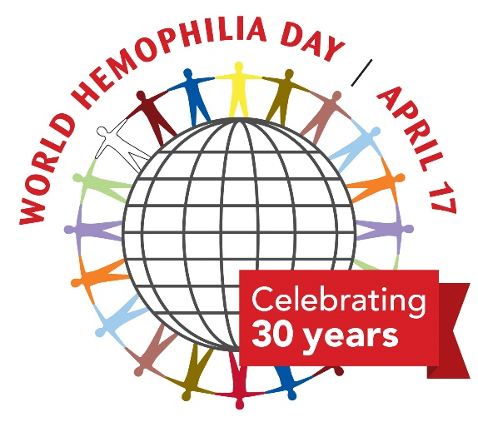

WORD FIND 2020

O Y D T R J N P X I Q F
Q T W D F Z X I L D A A
K H V X Z Y N W E S S C
E D E N P S F G X V F T
H A E M O P H I L I A O
P V L H N P S Y O X T R
O E D E E L B V P J R K
Y R A T I D E R E H O G
T N E M T A E R T U P N
Z E S I U R B T N I O J

Bleed | Bruise | Factor
Haemophilia | Hereditary | Joint
Port | Treatment | Vein
VWD

*Answer sheet available to download at www.haemophilia.org.au*

GLOSSARY

BLEED – In haemophilia, bleeding episodes usually occur inside the body, with bleeding in muscles and joints, such as ankles, knees and elbows

BRUISE – An injury causes tiny blood vessels called capillaries to burst. Blood gets trapped below the skin’s surface, which causes a bruise

FACTOR - A blood plasma protein that is an agent in the clotting process

HAEMOPHILIA – An inherited bleeding disorder where the blood doesn't clot properly. It is caused when blood does not have enough clotting factor

HEREDITARY – Passed in the genes from parent to child

JOINT – The place where two or more bones come together

PORT – A device put under the skin to give easy access to a vein for treatment and to protect veins from continued needle sticks.

TREATMENT – Medical care given to a patient for an illness or injury

VEIN – Blood vessel which carries blood from any part of the body back to the heart

VWD – People with VWD have a problem with a protein in their blood called von Willebrand factor (VWF) that helps control bleeding. They do not have enough VWF or it doesn’t work properly, and it takes longer for blood to clot and bleeding stop

Haemophilia Foundation Australia
P: 03 9885 7800
E: hfaust@haemophilia.org.au
W: www.haemophilia.org.au
